**IOT and Artificial Intelligent based Smart farming System using Cloud computing and Wireless Sensor Network**

**Abstract:**

As new technologies emerge, the Internet of Things (IoT) is increasingly used in rural areas, in addition to cities and factories. As the global population increases, it is essential to find strategies to boost agricultural productivity while reducing costs, saving time, and employing fewer people. IoT is utilised to fulfil these objectives. When farmers use traditional farming techniques, they usually engage in strenuous manual labour. Farmers reported that it was difficult to monitor the performance of their farms at any particular time or location. Using Internet of Things-connected devices permits varied objects to communicate with one another (IoT). The Internet of Things (IoT) is essential to enhancing agricultural productivity. Internet of Things (IoT) and wireless sensor networks are at the core of the "smart agriculture" technologies that are proliferating around the globe (WSN). One field that has made tremendous success in this way is precision agriculture. Researchers have been developing monitoring and automation systems for a variety of agricultural tasks in a number of laboratories. Using WSN, it is easy for IoT equipment on a farm to send and receive data. Utilizing the Kalman filter (KF) and prediction analysis, the proposed method captures noise-free data for transmission in cluster-based WSNs. This strategy is incredibly useful in WSN applications because it improves data quality for analysis while reducing the amount of additional work required to provide data. Utilizing prediction analytics, a decision tree is utilised to estimate agricultural productivity. This information is then relayed swiftly to farmers via the internet of things. The proposed system utilises the Internet of Things (IoT), Raspberry Pi, and a variety of sensors to increase food production. Thingspeak.com may be able to give an internet-based live data stream. With these portable instruments, farmers are able to monitor their crops at all times, from planting to harvesting. Additionally, they can obtain support from specialists as needed. This system is accessible around-the-clock, seven days a week. The technology can now detect and warn of animals, making the environment safer for everyone. Animals are becoming increasingly problematic in human cultures, compromising both the health of humans and the design of objects. This strategy has the potential to save the lives of both humans and animals.

**DESCRIPTIONS:**

In recent years, the digital divide between farmers and IoT devices has diminished. In the future, these devices will increase productivity by promoting ecologically friendly food production. In addition, they will aid in promoting environmental stewardship by reducing water consumption and enhancing the effectiveness of inputs and treatments. The Internet of Things can be used to create infrastructure that will aid in various farming operations. Examples include automatic irrigation systems, frost protection systems, fertilisation systems, and remote monitoring systems. Given this, it is crucial to offer farmers and researchers with a comprehensive picture of the Internet of Things' potential applications in agriculture. The article presents a comprehensive analysis of the study on the agricultural applications of the Internet of Things. This article aims to provide an overview of how the Internet of Things (IoT) is being utilised in agriculture. It will examine currently available IoT-based agricultural software applications, IoT-based agricultural devices, and the advantages of these technologies. Network congestion reduces processing time, making it increasingly difficult to employ cloud computing to store and analyse the growing amount of data created by IoT devices every day. Despite these challenges, cloud computing is becoming increasingly popular. As a result, cutting-edge technologies such as artificial intelligence, blockchain, and many others were created, and edge computing was born as a further answer to these problems. This paper aims to give a thorough evaluation of the benefits and drawbacks of all proposed architectures for Internet of Things-based smart farming. Traditional IoT systems reliant on cloud computing or centralised servers make tracking and controlling farms challenging, especially in rural areas with unreliable or nonexistent internet connectivity. There are also some matters that must be resolved immediately due to safety considerations. This prevents real-time data processing and raises the possibility of issues such as latency and bandwidth fatigue. Decentralization is presented as a way to circumvent these problems and find a workable solution. Edge computing is the use of adjacent processing and storage resources to meet the data and compute requirements of IoT devices. Increases the data transmission and reception speeds of Internet of Things devices and their associated backbone networks. Without edge computing, the Internet of Things would rely on networks and central processing units located in the cloud or a datacenter. Due to the frequency with which IoT devices and cloud storage providers send and receive data, however, reaction times may grow and operational efficiency may decline. By reducing the required bandwidth, edge computing facilitates the delivery of massive amounts of data via slow cellular networks or satellite connections. It also enables systems to operate when disconnected from the internet. With the aid of edge computing, the huge volumes of data created by Internet-connected devices may be utilised. Placement of analytics algorithms and machine learning models at the network's edge enables rapid data analysis and decision making. Edge computing collects and transmits data to a central server for analysis and long-term storage. Regarding agriculture, IoT technology shines brightest when applied to precision agriculture. Smart city agriculture and agronomy incorporate Internet of Things ideas into the design of precision agriculture. The bulk of "smart cities" in existence today are based on software-defined networks (SDN) and cyber-physical systems. Farming drones are just one example of how the Internet of Things is being utilised for human benefit. "Agricultural drones" are drones built for agricultural application. They are well-known for their inexpensive and superior sensors. With the use of these sensors, farmers can gain more from their crops and safeguard them. Smart greenhouses that employ hydroponic or aquaponic systems on a modest scale can also profit from the Internet of Things. Intelligent greenhouses are gaining popularity in urban areas because they help plants grow, produce more, and stay healthy. Additionally, they may monitor numerous features of fertiliser solutions. By providing infrastructure that automates, optimises, and enhances urban agriculture and precision agronomy in other ways, these enhancements have a substantial impact on the evolution of smart cities. In vertical agriculture, computers or mobile devices such as tablets and smartphones can be used to manage soil moisture and water content. It's amazing that the Internet of Things is being utilised in yet another sector. One application that mixes IoT and AI is Malthouse, an AI system that allows you to set up settings and schedules for precision farming and food production. There are now software solutions that integrate IoT and AI. IoT-based technologies have been effectively implemented in numerous applications. As a result, a growing number of companies are investing money and time in the development of IoT-based software for agricultural purposes. Now available on the market are several software packages designed to aid with a variety of farming chores. The AG-IoT unmanned aerial vehicle (UAV), for instance, actively looks for existing IoT devices on the ground and supports them in creating groups so they may share data. Agro-Tech collects and organises data from a large number of sensors spread throughout a specific area of the crop. In addition, the programme grants farmers access to this data, enabling them to keep a closer eye on their crops. Malthouse is an AI system that facilitates setups and schedules for precision agriculture and food production. This task can be accomplished remotely utilising Internet of Things devices equipped with cameras and Raspberry Pi cards. These are remote-accessible components of video surveillance systems for farms. Cropx, on the other hand, is adaptive irrigation software that helps farmers to maximise crop productivity with minimal water and energy usage. Cropx is the name of the company that developed the software. Using the farm management software Farmlogs, farmers may photograph the steps they take to protect their crops. Last but not least, MbeguChoice is a piece of software that enables farmers to select the best seed vendors in their region who provide drought-resistant seeds. The Internet of Things facilitates remote agricultural monitoring by collecting data on weather, humidity, temperature, and soil fertility. Thanks to modern technology, farmers are able to monitor their crops from anywhere and at any time. However, wireless sensor networks enable the control of the farm's environment and the automation of numerous tasks. Several studies in this article utilise wireless cameras to monitor crop growth in real time, for instance. Drones have been utilised for precision agriculture, and in certain instances, farmers' cell phones have been used to inform them of the status of their crops. Wireless sensor networks, cloud computing, middleware management systems, and mobile application development are among the most exciting technologies that could be integrated with the Internet of Things to generate new agricultural solutions. The Internet of Things is already an integral part of how the agriculture industry addresses several issues. We did a literature review in order to identify the most significant Internet of Things (IoT) applications in agriculture, as well as the most significant IoT-based software and agricultural devices. The Internet of Things applications for farmers developed by Aim Works were evaluated using multiple sources of research. Clearly, if food crops are to be farmed in a sustainable manner, more research initiatives concentrating on environmental issues are necessary. In addition, it is essential to note that the topics presented in this work are essential for everyone working in agriculture. This is essential since it emphasises the need of conducting additional study.

**DRAWINGS:**

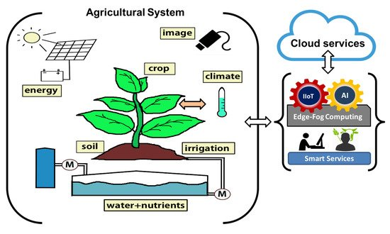

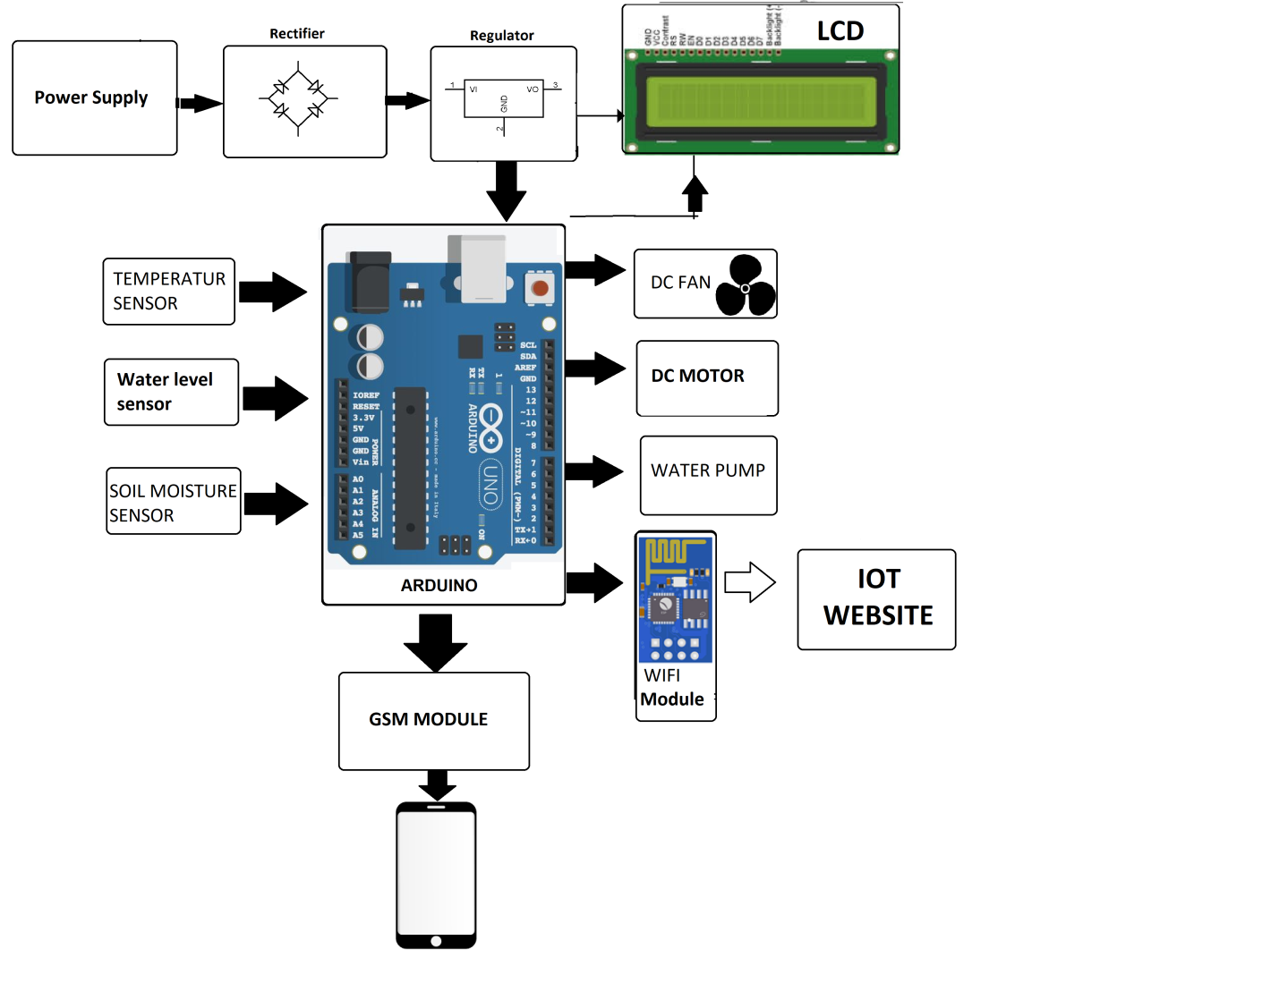

**CLAIMS**

1. IOT and Artificial Intelligent based Smart farming System using Cloud computing and Wireless Sensor Network a cutting-edge science technology.

2. IOT and Artificial Intelligent based Smart farming System using Cloud computing and Wireless Sensor Network of claim 1, wherein said that it can be used for a variety of purposes.

3. IOT and Artificial Intelligent based Smart farming System using Cloud computing and Wireless Sensor Network of claim 1, wherein said the proposed system is more accurate and faster.

4. IOT and Artificial Intelligent based Smart farming System using Cloud computing and Wireless Sensor Network of claim 1, wherein said that in this paper, we analyzed and discussed various aspects.

5. IOT and Artificial Intelligent based Smart farming System using Cloud computing and Wireless Sensor Network of claim 1, wherein said that in recent years, IoT, AI become a hot topic in medical system.

6. IOT and Artificial Intelligent based Smart farming System using Cloud computing and Wireless Sensor Network of claim 1, wherein said that a reliable and efficient system for monitoring variables.

7. IOT and Artificial Intelligent based Smart farming System using Cloud computing and Wireless Sensor Network of claim 1, wherein said that this research looks at all of the important and recent work that has been done so far, as well as its limitations and challenges.

8. IOT and Artificial Intelligent based Smart farming System using Cloud computing and Wireless Sensor Network of claim 1, wherein said that Additional disease types may be studied in the future.

9. IOT and Artificial Intelligent based Smart farming System using Cloud computing and Wireless Sensor Network of claim 1, wherein said that a future study could compare the performance of various AI algorithms.